# Table View Draft Fall 2021

The objective here is to show that you have made satisfactory progress on your site. You must have everything from the mobile PLUS the elements below. The MOST important part is the responsive layout, followed by the styling.

**Your name: Yue Wang**

**Link to your deployed site: https://wyjessica860.github.io/final_project/**

1. What elements use grid and which pages are these elements on? How did you use grid differently from the homework? Why did you use the number of columns/rows? Did you use Inspect Element to check that removing display: grid changes the page? (Include screenshot if desired.)

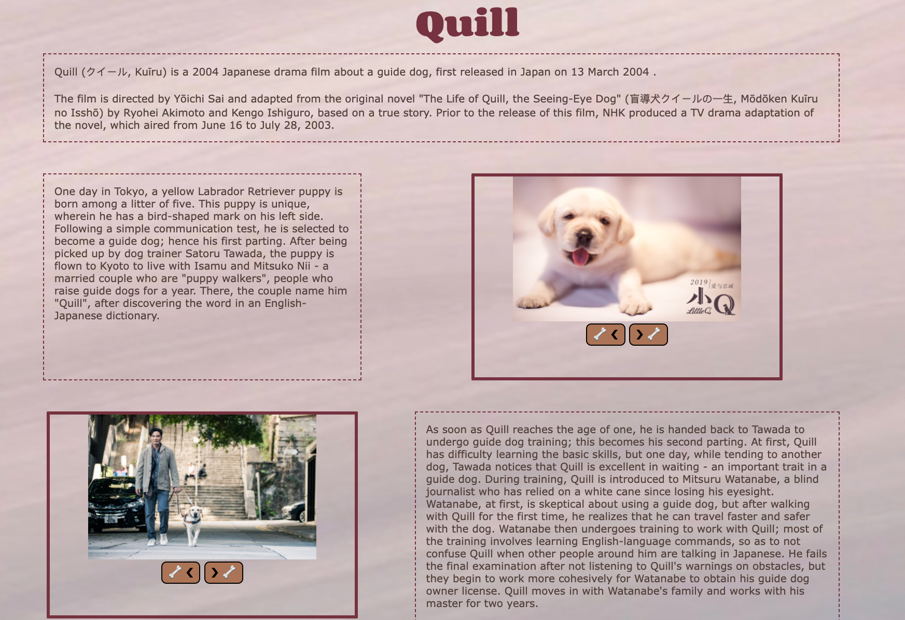

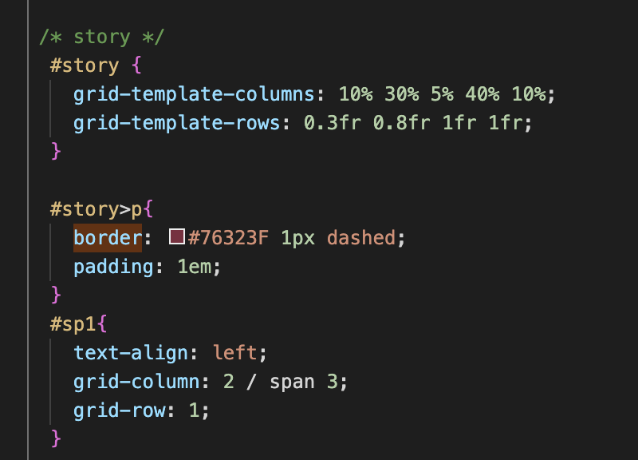

Grid will definitely change this page, since if removed, the elements will align from top to bottom rather than aligning in two columns. Also, I leave some space for each row by 10% so that the items on each row will not take the whole line to help readers watch it more easily.

(not use grid)

Comparing with the homework, I use the percentage as the size of the columns so that it can fit the page better.

1. What elements use flex and which pages are these elements on? How did you use flex differently from the homework? Which different supporting properties did you use, e.g flex-direction, flex-wrap, justify, align? Did you use Inspect Element to check that removing display: flex changes the page? (Include screenshot if desired.)  
   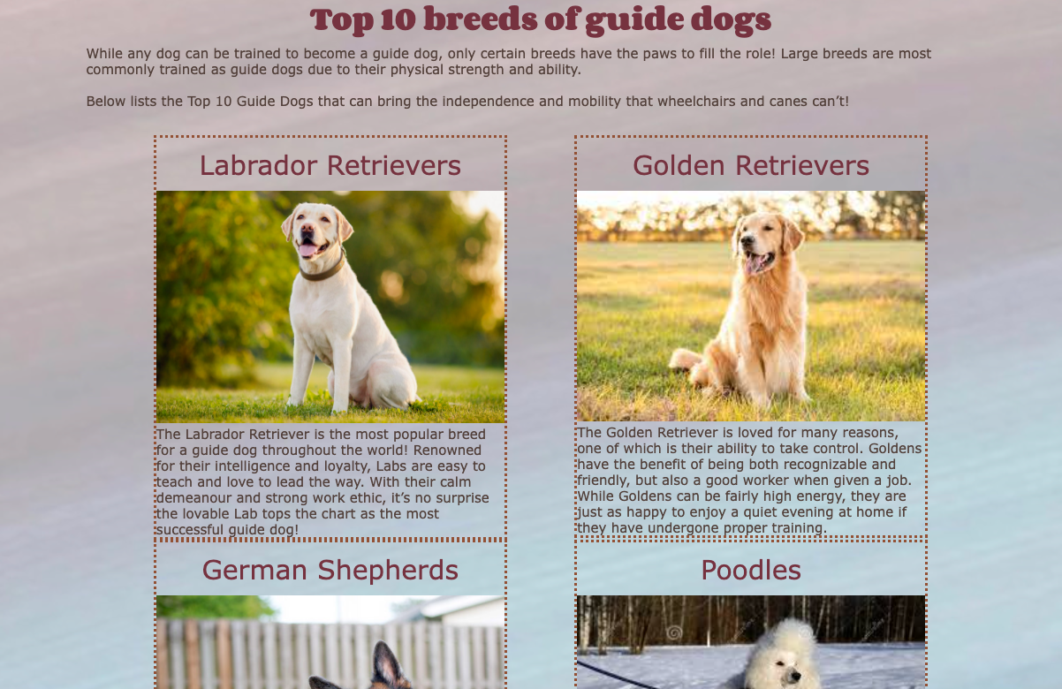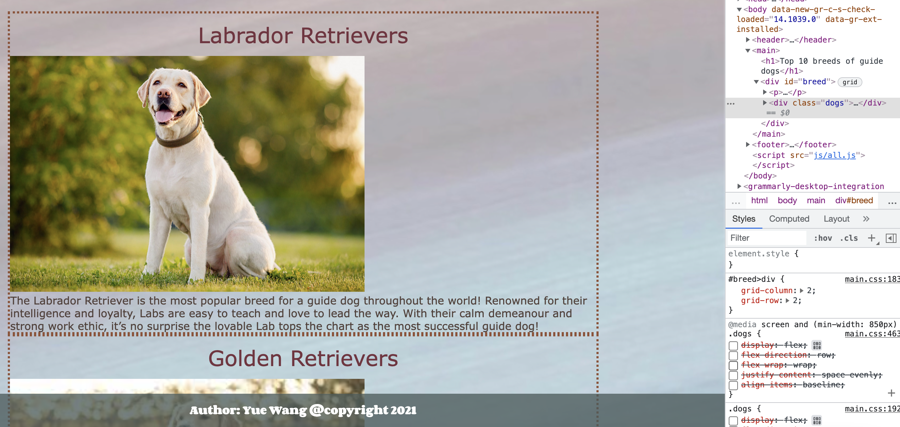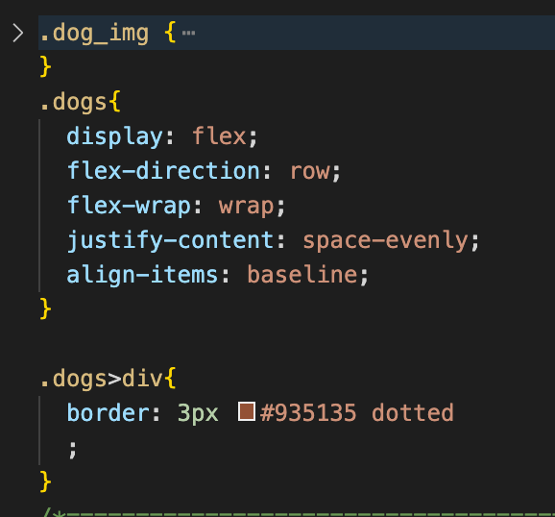

I use align-items: baseline and justify-content spece-evenly, which is different from the homework using justify-content center and align-items: center;

1. What did you do to make your pages particularly visually appealing? How did you come up with your color scheme? Tell us more about your font choices, image editing, etc. I am sure there are things that you did that we can't easily see.

1,beautiful color scheme and cute font family chosen. User friendly size chosen and grid distribution. To make the page more hamounious.

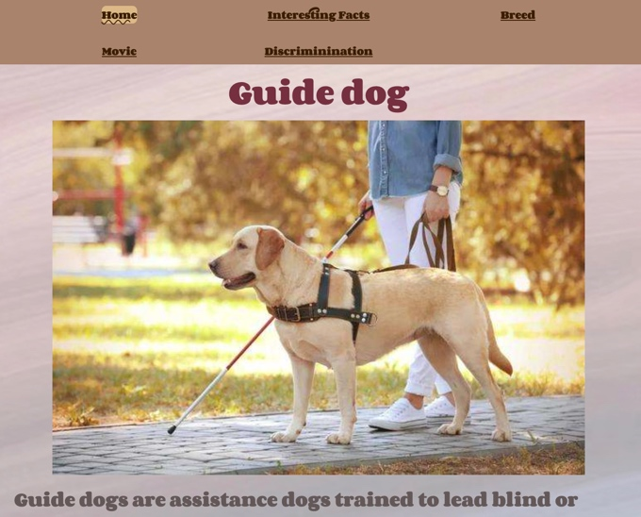

2, flip cards animation designing to add more interactivity

3, two interactive button added to construct a photo gallery: so that the photo is better organized



4, animation of the sidebar and the content

1. Is “Skip to Content” available on every page - It should be hidden on the page load and appear on the first tab.  
   Yes
2. Tell us about your Responsive Design. Why did you pick that particular value for your media query? What is changed in the layout? What is changed in the styling ? The expectation would be that AT A MINIMUM your grid layout changes on at least one page and your navigation changes on every page.

The breed and movie page changes its alignment.

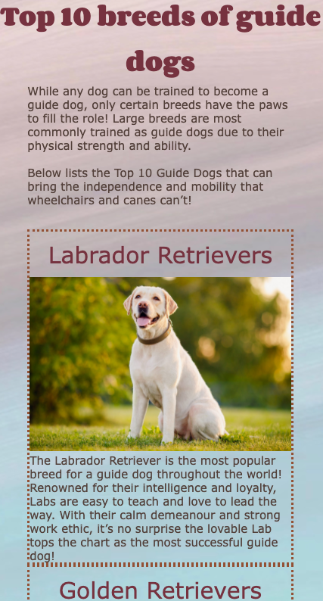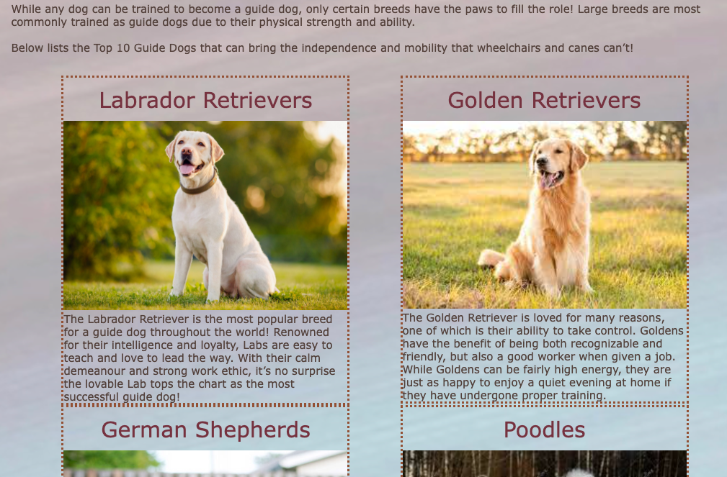(by flex)

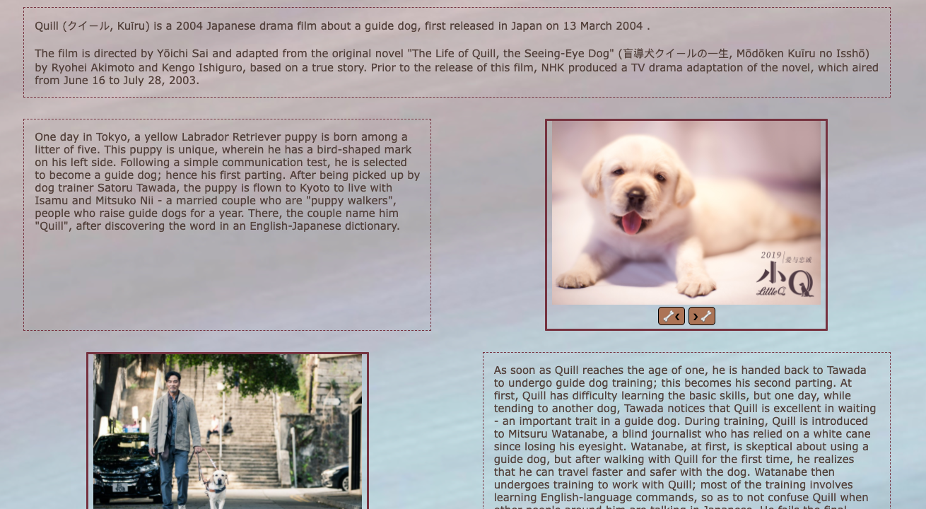 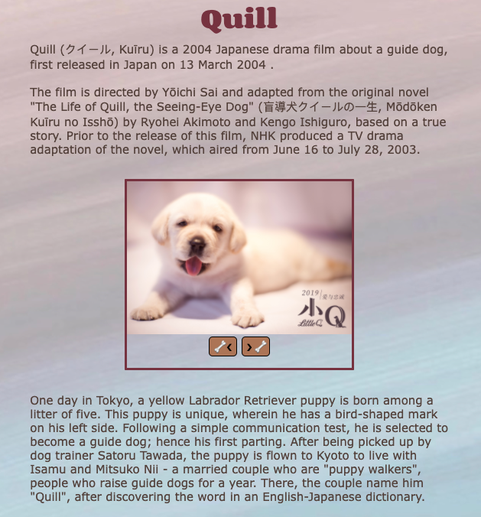(by grid and add the border to make the grid clearer)

Navigation:





The card become flipped:

Since I think it is better for mobile to use a click button, while flip card is more interesting to attract readers in tablet view.

1. Validation - Include screenshots of **two** of your pages validating on aXe and Wave. If you have errors that you don’t think should count against your grade, include documentation.
2. 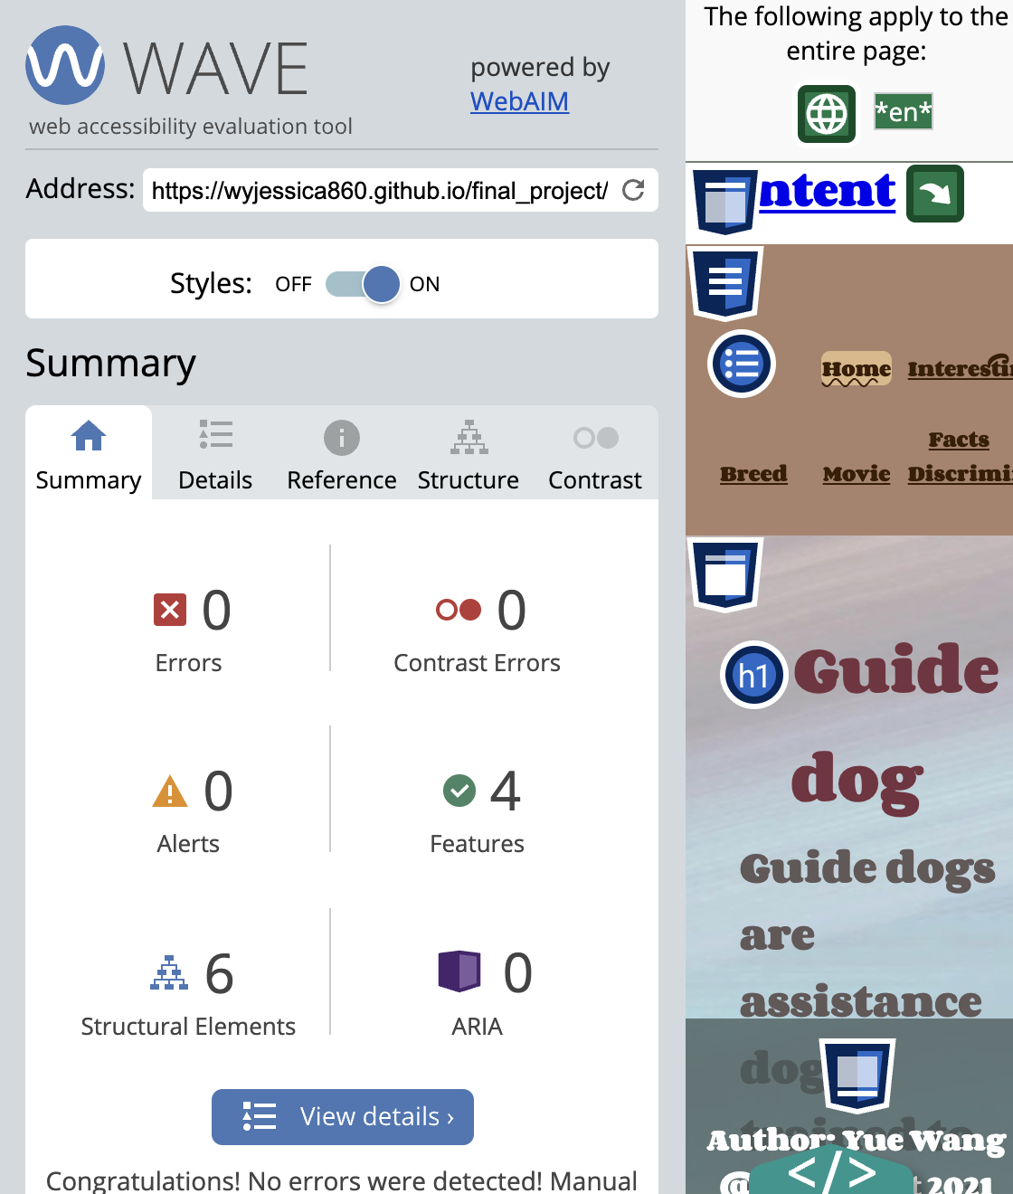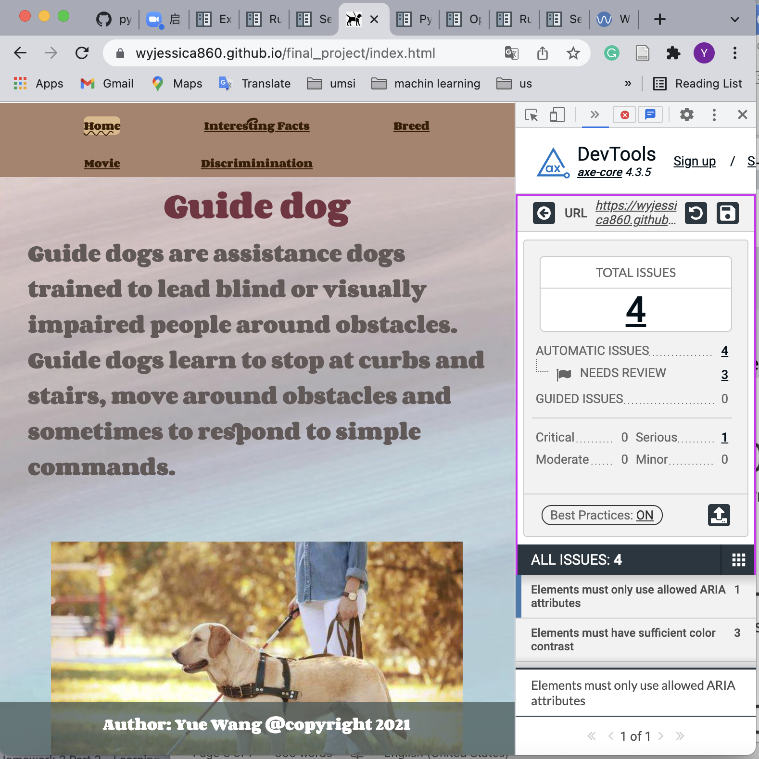

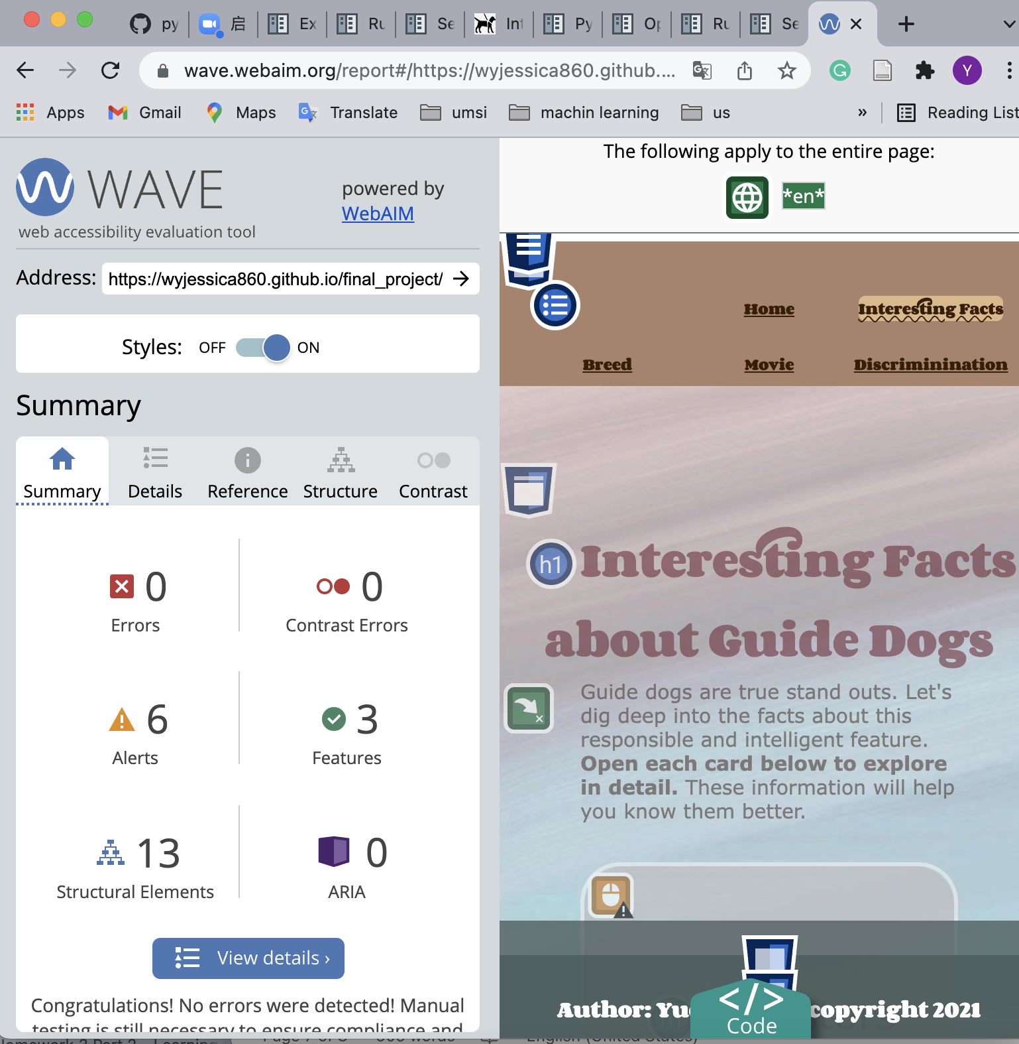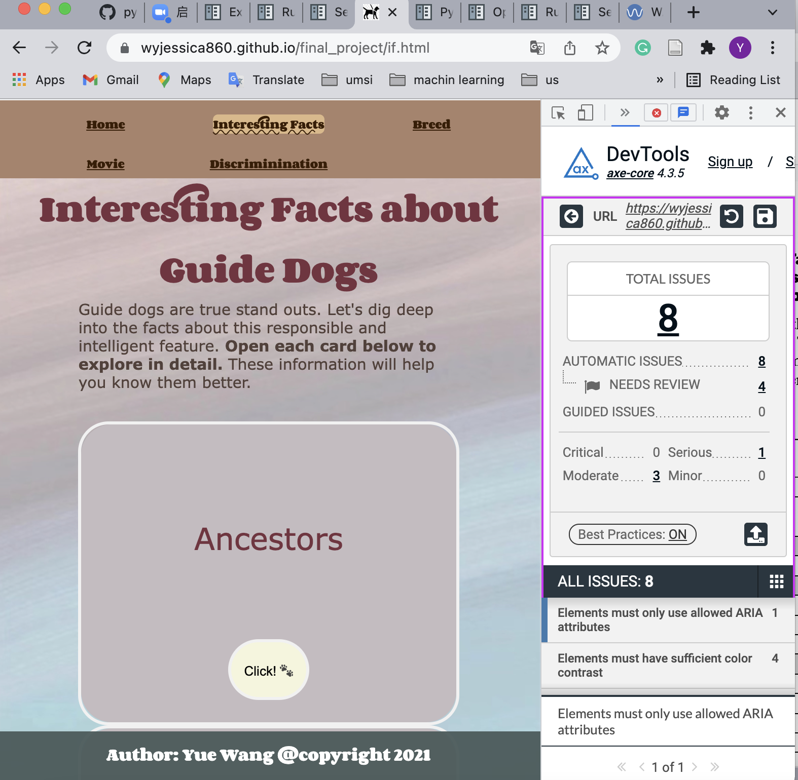

No errors in wave, and in axe, I have errors of not have sufficient color contrast, which is part of my design to make the elements more coordinate, therefore, it does not count. Also, I have checked that my tag are all under direction, therefore, the aria attribute is not a problem.

1. Do you have the minimum content? How do you indicate the current page WITHIN the links in the navigation? (Make sure you are not using just color) Make sure you have a footer!!  
   Yes
2. Check your site for other issues. Are you using the html5reset style stylesheet? Did you remember to include the viewport meta tag? Do you have console errors? Did you use proper naming conventions (no uppercase letters or spaces, mnemonic file names, etc.) Did you check that your content is still visible in mobile view?

Yes

When you submit the link to this document in the comments section make sure that you have set the share permissions to allow anyone with the link to view and/or comment.